Concur
Reference Guide
Expense
03/22

Table of Contents
Travel Expense Report 2
Creating an Expense Report 2
Adding Expenses to the Report 3
Out-of-Pocket Expense 4
Personal Car Mileage 5
Itemizing Expenses 6
Allocating Expenses 8
Attaching Receipts 9
Email or Forward Receipts to your Concur Profile 9
Receipts Captured with Concur App 9
Uploading Scanned Documents 10
Special Travel Situations 11
International Travel 11
Expensing a Cash Advance 13
Blanket Mileage Claims 16
Submitting an Expense Report 16
Tracking Status of an Expense Report 17
Acting as a Delegate 18
Printing an Expense Report 19
Correcting and Resubmitting an Expense Report 20

Travel Expense Report
All CSU related travel for faculty and staff must have an approved Travel Request before an expense report can be created.
Per CSU Travel Procedures, Section IX: A "Travel Expense Claim must be submitted to the campus Travel Reimbursement office within 60 days of the end of a trip unless there is recurrent local travel, in which case claims may be aggregated and submitted monthly."
Please be aware Approved Travel Requests will automatically close on day 61 after the travel end date. In order to submit a late expense report, the request will have to be re-opened. The request will not be re-opened until an exception request form is provided with approval obtained from David Crozier.
Creating an Expense Report
To create a report:
- Click Request on the header toolbar, and then select the tile for the specific trip request.
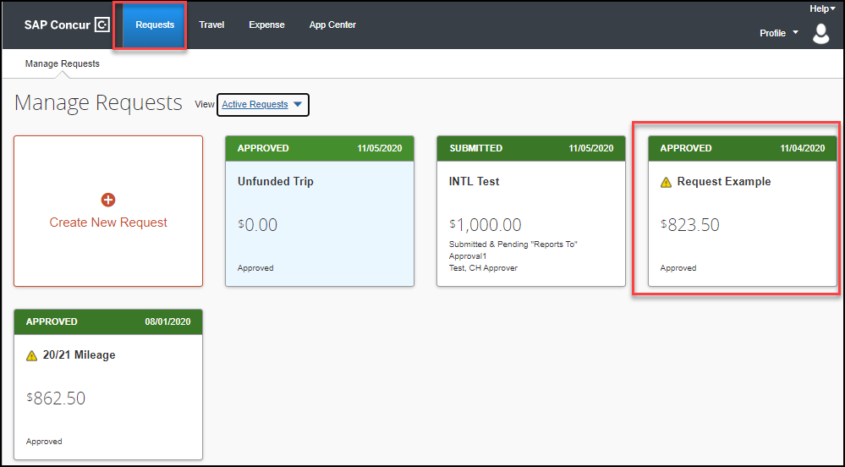
Select Create Expense Report.
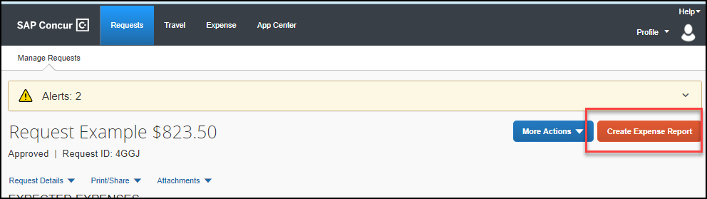

Adding Expenses to the Report
There are various ways to add expenses and compile a complete expense report. Overall, the goal is to reflect all costs associated with a trip, regardless of payment method.
Travel Credit Card/Ghost Card Charges
You can add Concur Travel card transactions to an expense report in these ways:
- From the open expense report (Add Available Expenses)
- From the Available Expenses section (Expense > Manage Expenses)

- From the open expense report, click Add Expense. Select related expenses and then Add to Report button.
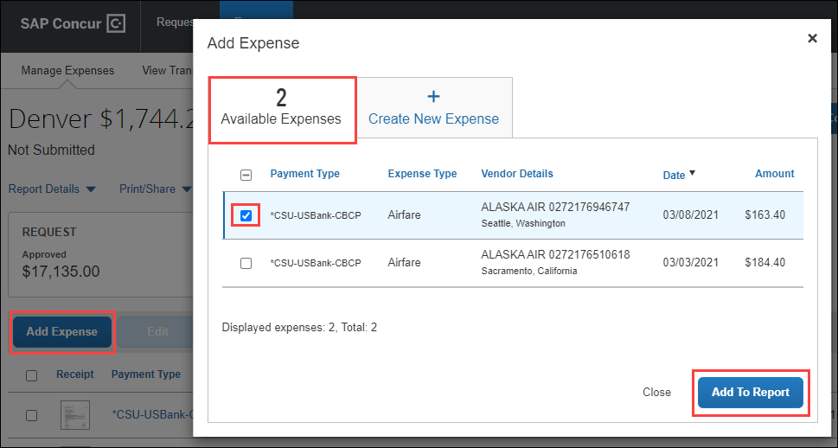
  - Verify or update the Expense Type classification of the imported credit card transactions or any other required fields that need to be populated.

- From the Available Expenses section (Expense > Manage Expenses), select each transaction that you want to assign to the current expense report.
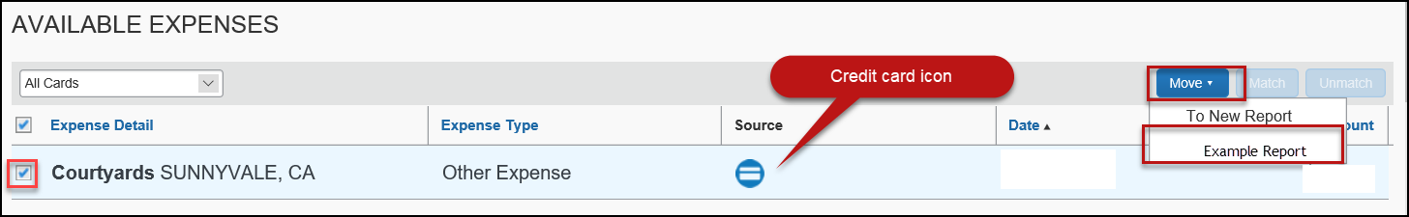
  - Click Move and select the related expense report.

  - Verify or update the Expense Type classification of the imported credit card transaction.

Out-of-Pocket Expense

To add an out-of-pocket expense to an Expense Report:
- From the open report, click Add Expense.
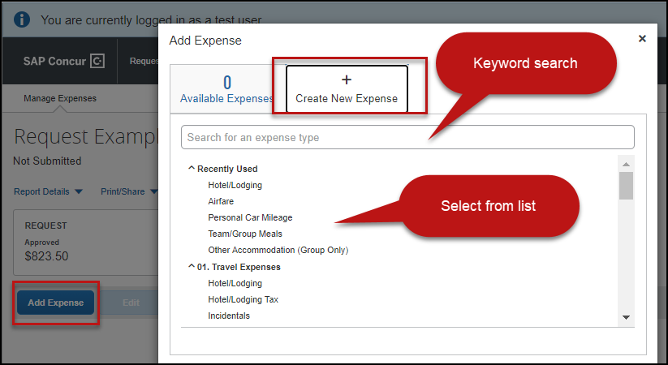

- On the New Expense tab, click the appropriate expense type. Each expense type will have their own set of required fields and configuration.
- The page refreshes, displaying the required and optional fields for the selected expense type.
- Complete the required and optional fields. Click one of the following:
  - Save
  - Itemizations - to itemize the expense and classify as two different expense types (i.e. dinner and parking). NOTE: Hotel expenses require itemization to break down nightly rates, taxes, etc.
  - Allocate - to allocate the expense between various chartfields as applicable
  - Attach Receipts - to upload and attach receipt images
  - Cancel - to exit without saving this expense
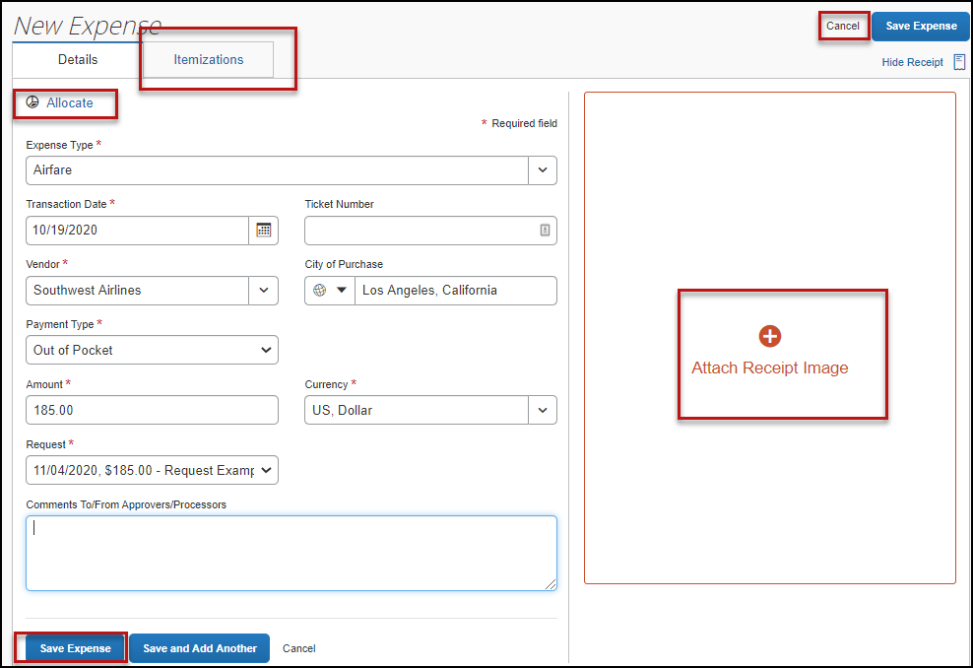

CSU and campus specific audit rules are integrated into the system. When adding an expense that requires a certain action an alert message will appear:
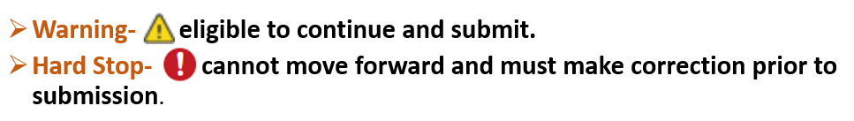
Personal Car Mileage
You must register a car for the applicable mileage type to be reimbursed for mileage. For instructions on setting up your vehicle(s), see the Personal Car section within the Concur Reference Guide- Profile Setup.
To Create a Car Mileage Expense
- With the Expense Report open, on the New Expense tab select the Personal Car Mileage Expense Type. The mileage form will open with the required and optional fields displayed including the Mileage Calculator link.
- Complete all required and optional fields as appropriate.
- Click the Mileage Calculator link and review and update the route as appropriate. If round trip mileage should be calculated, click Make Round Trip.
- Click Add Mileage to Expense.
- Click Save.
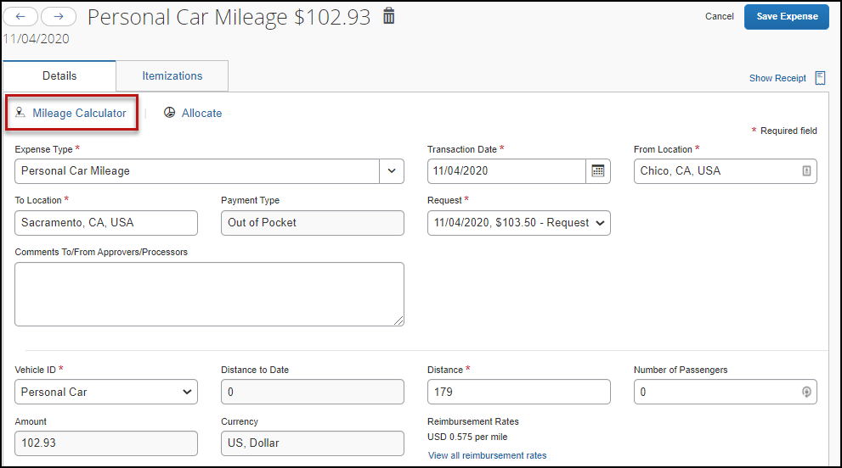
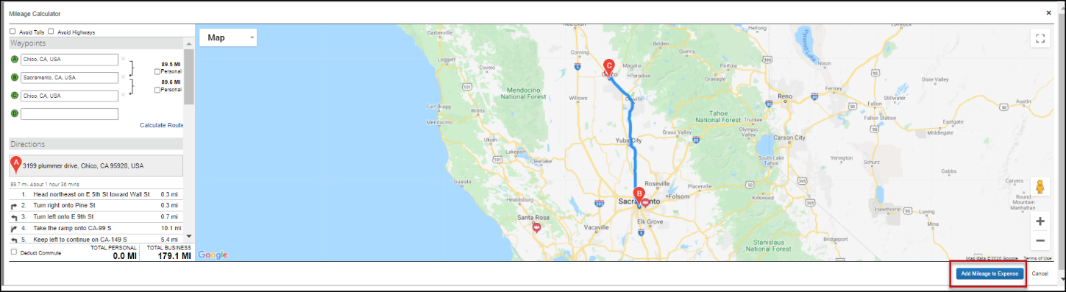
Itemizing Expenses
Use the Itemize feature to account for transactions that should be charged to multiple expense types (accounts codes). Itemization should be completed prior to Allocation (charging to multiple chartfields).

To itemize a general expense:
- Add the expense as usual and then click the Itemizations tab. The itemized amount must match the total expense.
- Select Create Itemization button, then select the expense type that applies to the first itemization. The page refreshes, displaying the required and optional fields for the selected expense type.
- Complete the fields as required. Click Save Itemization.
- Repeat step 2 for each additional itemization on the Itemization tab, until the Remaining amount is $0.00.
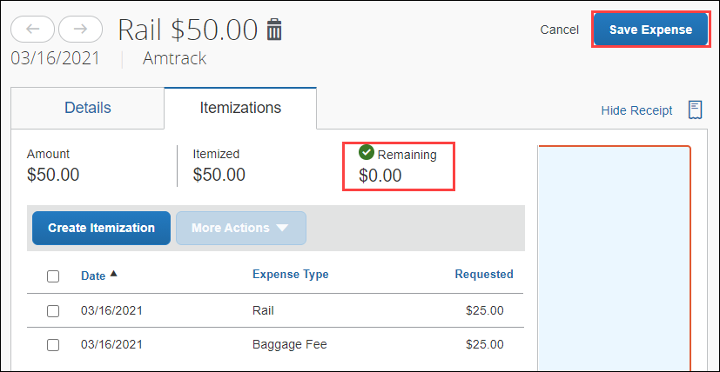
- Click Save Expense.
- The expense will now reference an “itemized” note under the amount.

To itemize a hotel expense:
A hotel bill typically contains a variety of expenses including room fees, taxes, parking, meals, Wi-Fi charges, and maybe personal items. You must itemize these expenses so that they can be reimbursed correctly.

To create a lodging expense:
- With the Expense Report open, on the Create New Expense tab select the Hotel/Lodging expense type. The lodging form will open with the required and optional fields displayed.
- Complete all required and optional fields as appropriate.
- Click the Itemizations tab then Create Itemization button. Search/select the Hotel/Lodging expense type.
- The number of nights and dates involved appear automatically.
- Select The Same Every Night or Not the Same depending on the respective hotel details. If not the same each night (e.g. increase for weekends, etc.) this option will let you note the differences from day to day, otherwise select the same every night to itemize the full cost of stay by respective classification.
- Enter the Room Rate, Room Tax, and Additional Charges.
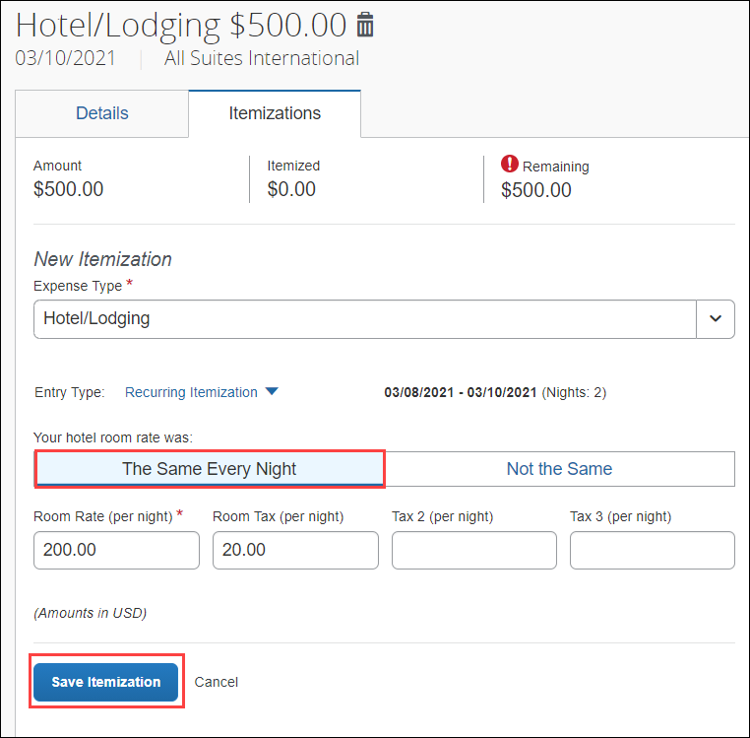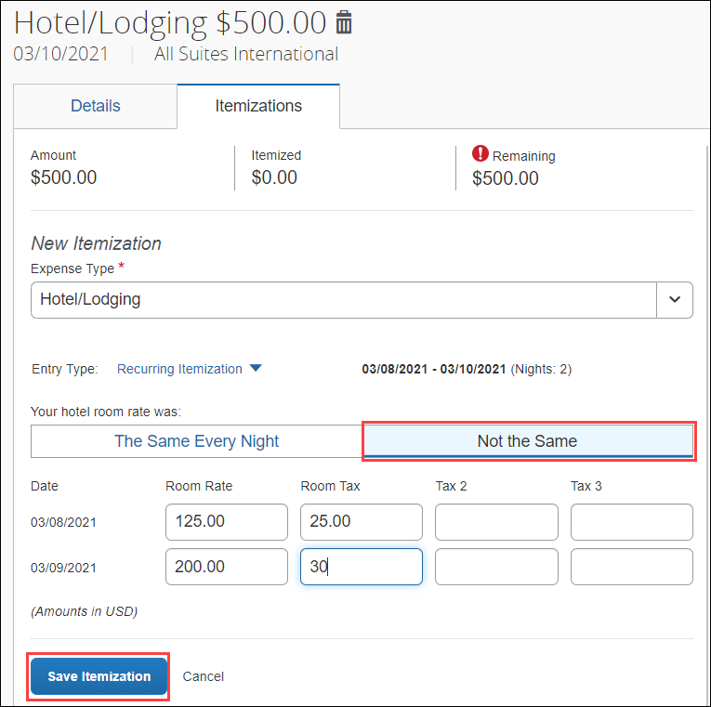
- Click Save Itemization.
- Repeat step 3 for each additional itemization, on the Itemization tab, until the Remaining amount is $0.00.
- Click Save Expense.
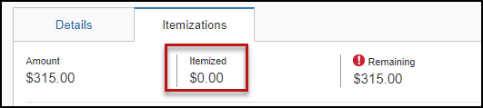
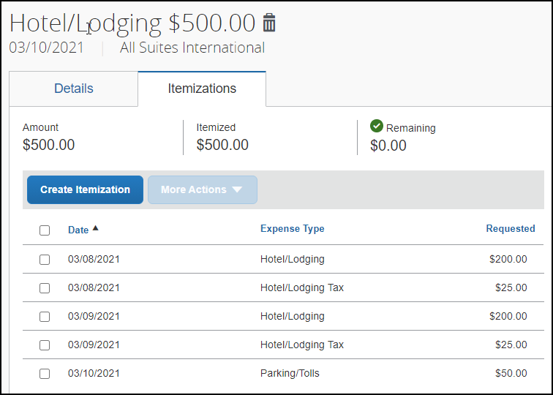
If there is a remaining amount to be itemized (other charges, for example, for parking or meals), the remaining amount is displayed in the Remaining field. Continue to itemize the amounts until the balance is $0.00.

Allocating Expenses
The Allocations feature allows you to allocate selected expenses to multiple chartfields. This should be performed after the Itemization if allocating to multiple expense types.

To allocate:
- Allocate single expense - With the report open, select a single expense and click Allocate. Select Percent or Amount, then Add and enter the new chartfield designation.
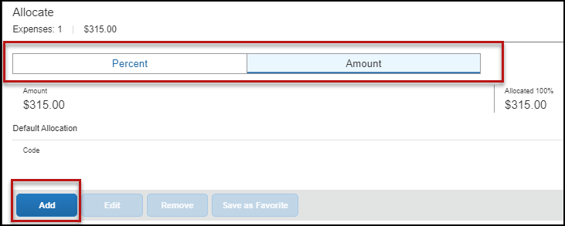
- To allocate multiple expenses (or the entire report), select the expenses and then select the Allocate button.
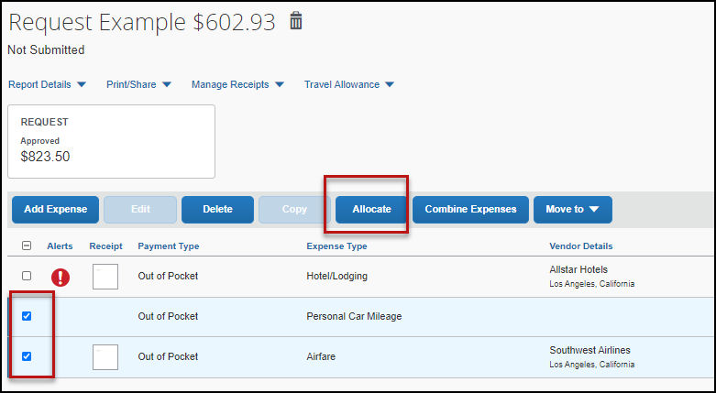
Select Percent or Amount, then Add and enter the new chartfield designation.
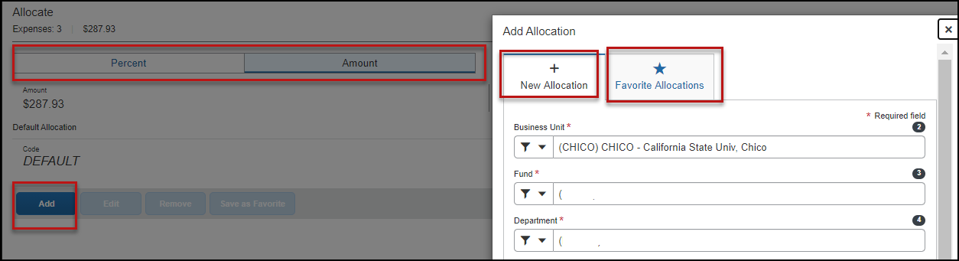
- Click Save.

If there is a need to allocate to multiple chartfields, click Add. The allocation box will pop-up to enter a new chartfield.
Attaching Receipts
Using Available Receipts Library
Users can upload images to the Available Receipts library which stores the receipt until the user is ready to attach it to an Expense Report. Receipts can be uploaded to Available Receipts using various methods.
Email or Forward Receipts to your Concur Profile
- Before emailing receipts to the Available Receipts library, you must verify your email address for verification in the Personal Information section of your Profile.
- Click Profile > Profile Settings. The Profile Options page appears.
- On the left-hand side of the screen, click Personal Information.
- On the Personal Information screen, scroll down to the Email Addresses section.
- Follow the below steps to verify your email address:
  - Once you have saved an email address, click Verify.
  - Check your email for a verification message from Concur.
  - Copy the code from the email message into the Enter Code box next to the email address.
  - Click OK to submit the code and complete verification.
- Prepare an email to receipts@concur.com, attach the images, and send the email. The available file formats are PDF, PNG, JPG, JPEG, HTML, TIF, OR TIFF.
or
- Forward an existing emailed receipt to receipts@concur.com.
Receipts Captured with Concur App
Any receipts captured using the Concur app will automatically place the images in your Available Receipts library and can be attached as described below.
To Attach a Receipt Image to an Expense Entry Using Available Receipts
- In the Expense Report, select an expense entry to open it in Detail view.
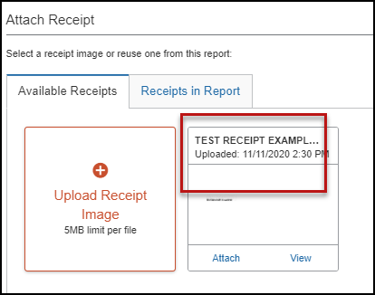
- Click Attach Receipt Image > View Available Receipts.
- Select the appropriate image and choose Attach. Click Save. The receipt column will be populated, and you can hover over or click the receipt box to view the receipt attached.
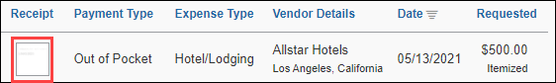
- You can also attach a receipt by clicking on the plus sign (+) within the expense line.
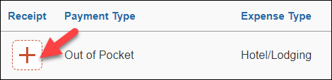

Uploading Scanned Documents
Files scanned and saved to a folder on your computer may be uploaded directly into an Expense Report using the following steps:
Scan the documentation into a .pdf, .png, .jpg., .jpeg, .html, .tif or .tiff file; 5 MB limit per file.
- With your transaction open, select Attach Receipt.
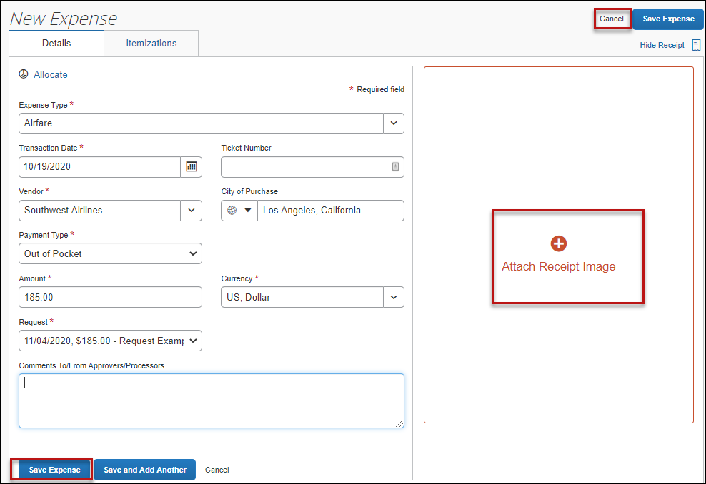

- Browse your computer to find the scanned document.
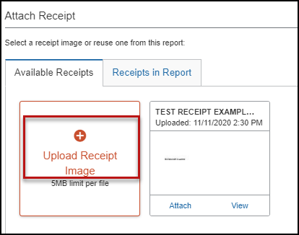

- Click Attach.
Special Travel Situations
International Travel
International, Alaska & Hawaii trips will require Travel Allowance itineraries to be created to utilize GSA per diem amounts, which are used as ceiling amounts for related expenses.
- Create or open your related expense report and select the Travel Allowance hyperlink, then Manage Travel Allowance to build your trip itinerary.
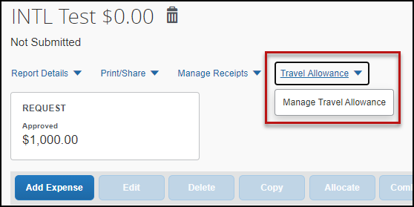

- The Travel Allowances window will appear allowing you to build your trip itinerary. Select Create New Itinerary and enter the first leg of your trip and click Save.
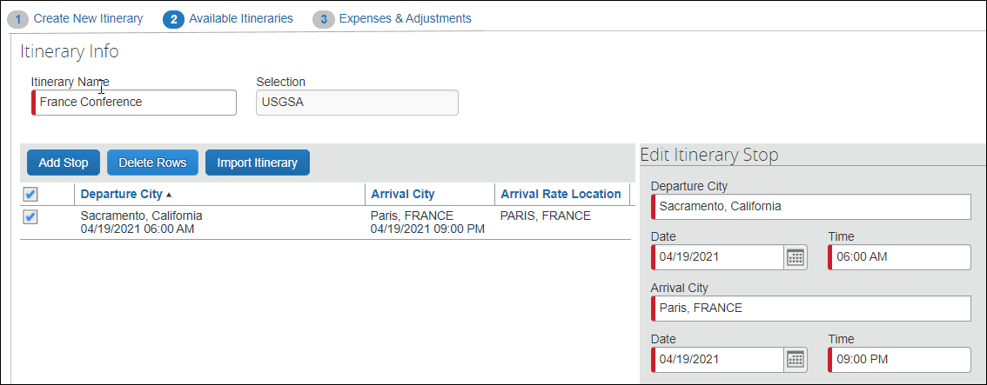
- Continue entering all legs of the trip by selecting the Add Stop button. An itinerary must consist of at least 2 legs: one leg for departure details and a second leg for your return details.
- When all portions of the trip are entered, click Next.
- On the Available Itineraries tab, you can view the itinerary that you have assigned to this trip.
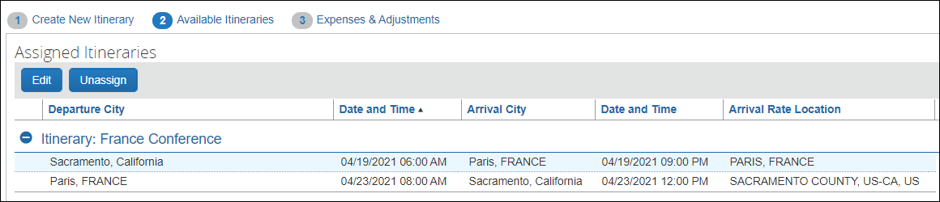

- Click the Expense & Adjustments tab to mark any meals which were provided during your trip. Then click Create Expenses to return to the expense report and add trip costs.
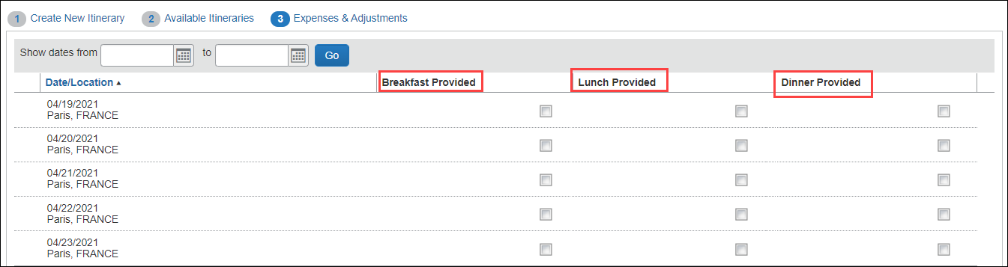

- You can begin adding either out-of-pocket expenses and/or University Credit Card transactions to your Expense Report.

Converting Foreign Currency Transactions
- With the Expense Report open, click Add Expense, and then enter the appropriate information in the required and optional fields (required fields are indicated with a red asterisk).
- For the Amount field enter the amount spent in foreign currency. The correct currency should populate based on the City of Purchase information you entered. If needed, you can change the currency from the list to the right of the Amount field.
- Expense will calculate the amount in USD.
- If expense amount is already in USD, enter amount in Amount in USD field and it will calculate the foreign amount for you.
- Complete the remaining fields as appropriate and make sure the Travel Allowance box is checked before saving the expense. This is what will be used to check the amount against the GSA travel allowance rates for that specific destination. If this box is not checked the report will not be able to be submitted until that occurs.

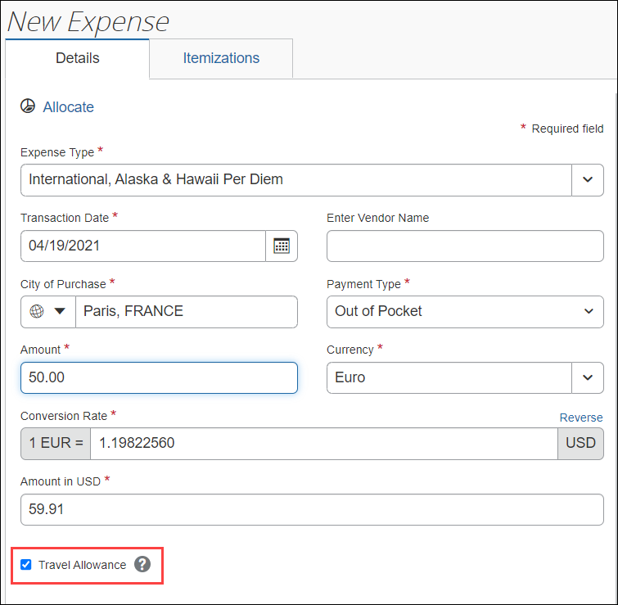
- Review summary of actual costs in relation to allowance ceiling. Select Travel Allowance hyperlink, Manage Travel Allowance and then select the Reimbursable Allowances Summary to see the breakdown. The example below intentionally shows an expense more than the allowance ceiling to demonstrate the adjustment that will be made to the reimbursable amount of the traveler. Actual expenses, up to the allowance ceiling, are reimbursable.
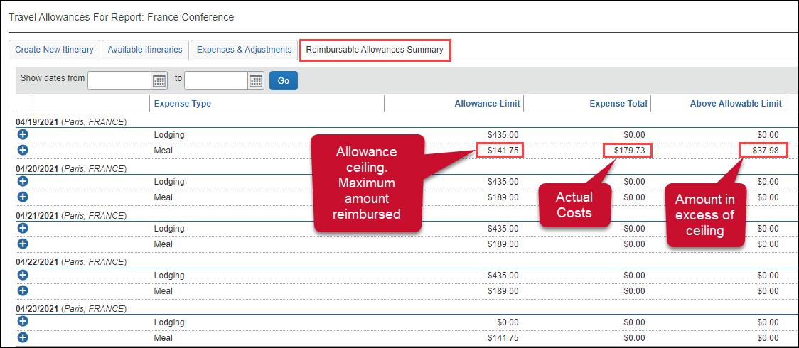

Expensing a Cash Advance
If you had a cash advance issued, you will need to expense the cash advance with your expense report for the associated trip the advance was used for. Cash advances are reserved for competitive team travel or other extenuating circumstances.
To Expense a Cash Advance (Fully utilized)
- Click Request on the header toolbar, and then select the tile for the specific trip request. Select Create Expense Report.
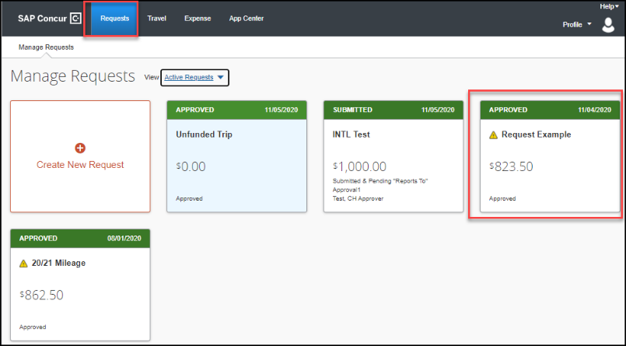
- At the top of the report, you will see Outstanding Advance. This should be the amount you received for the cash advance.
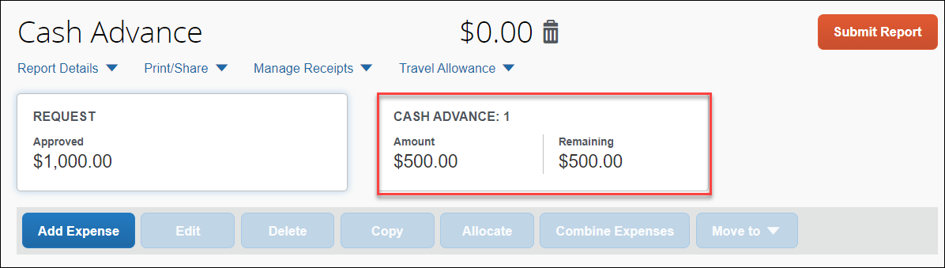

- Continue to enter your expenses as normal. When you enter an out-of-pocket expense, the outstanding cash advance balance will reduce.
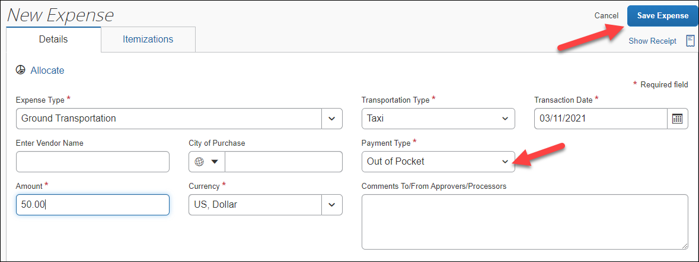

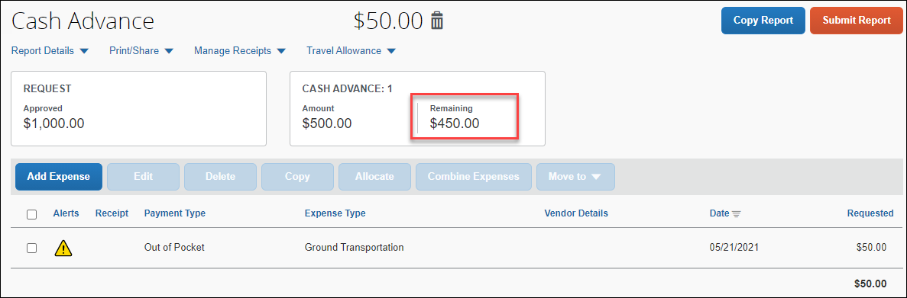
When the Outstanding Advance balance is zero, then the cash advance has been fully utilized. If you have additional out-of-pocket expenses, you will receive the balance you paid out-of-pocket minus the cash advance amount.
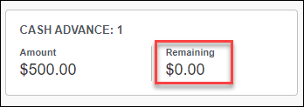
- Make sure all expenses are entered, and receipts have been attached. Click Submit.

A pop-up window will appear and state Report Totals with a summary of the expense totals and disbursements.
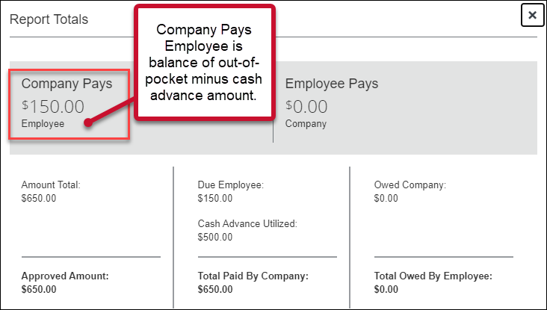
To Expense a Cash Advance (Excess Funds to be returned to the University)
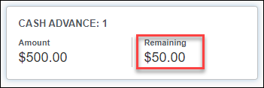
If there are funds still available from the advance after accounting for all expenses, you will see two messages.
- At the top of the screen:

- The following message will appear when you attempt to submit the expense report.

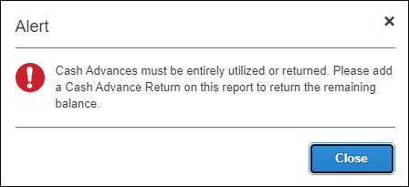

All excess funds must be returned to the University before you can submit your report.
To Pay Back the Excess Funds and Enter Returned Cash Advance Amount
- Go to the Seawolf Service Center office to return the excess funds. Cash and checks are accepted. The amount will be shown under Outstanding Advance. Note, the university will be monitoring activity and reaching out to any individuals that need to repay the campus, with relevant instructions.

Blanket Mileage Claims
There are situations where a travel request may be submitted, for mileage only, for an entire fiscal year. This is generally applicable to site supervisor travel around the area to supervise our students placed in clinical or school sites. While the travel request covers the full fiscal year, an expense report can be submitted monthly at the closure of each calendar month. Start the expense report like any other, note the total miles for that month. Enter in the mileage for the month or reporting period and submit for approval.

Submitting an Expense Report
To Submit Your Expense Report
- On the Expense Report page, click Submit Report.
- The Final Review window appears with the User Submit Agreement. By clicking Accept & Continue, the user is accepting the terms and conditions of the agreement.

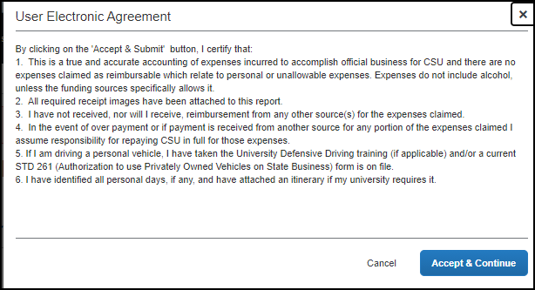
If you cannot successfully submit the report, a message appears describing the report error or exception. Correct the error, or if you require help to complete the task, contact Accounts Payable/Travel, apinvoice@sonoma.edu.

Tracking Status of an Expense Report
You can review the status of your submission in two different ways. Either way will show you what stage of the approval workflow your report is in.
When logged in you can select the Expense module and take note of the status on that report’s tile:
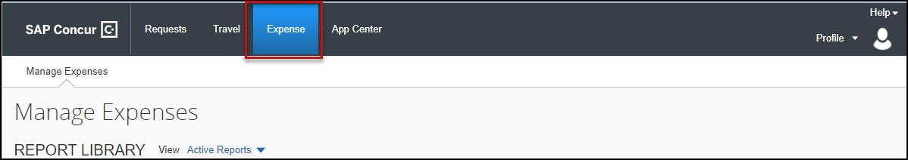
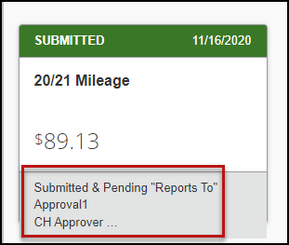
Alternatively, you can open the expense report and select the Report Details hyperlink, then select Report Timeline.
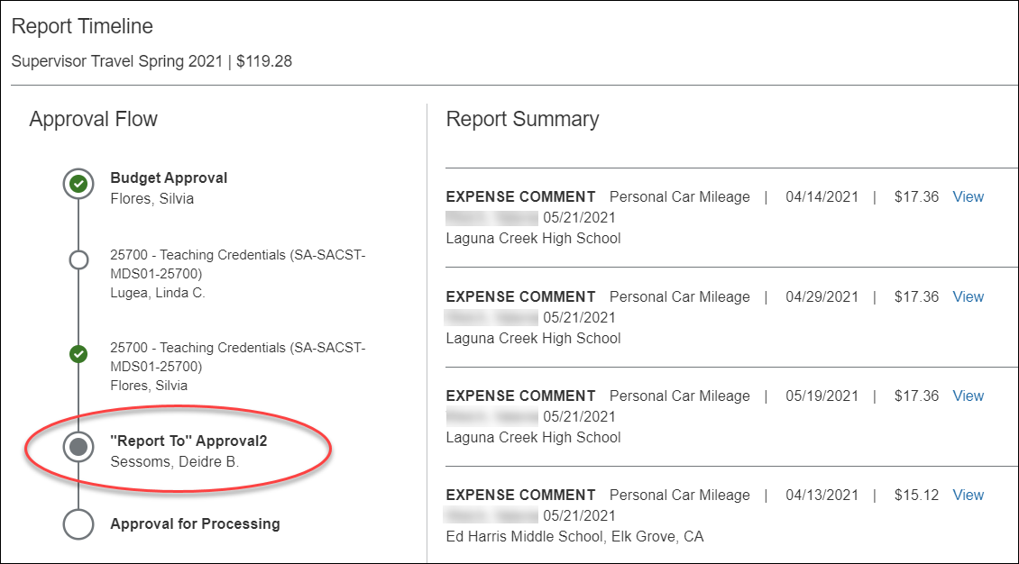
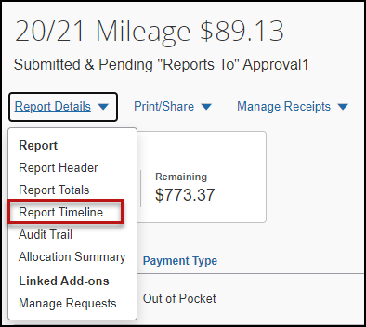
The Report Timeline will show what approvals have occurred thus far and where it is in the flow.
In the example to the right, this report is with the “Reports To” Approver2.

Acting as a Delegate
If you have been assigned to work as a delegate, your delegator will define which tasks you can complete, such as preparing reports, etc.
To Work as a Delegate
- Click Profile > Act on behalf of another user.
- Type the name or select the appropriate delegator's name in the drop down.
- Click Start Session.
NOTE: Notice that the Profile menu now displays Acting as and shows the name you just selected.
- You are now officially working on behalf of that person. Complete the normal processes of creating reports, attaching receipts, etc.
To select a different user, follow the same steps but click a different name.
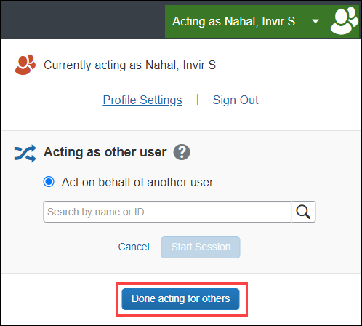
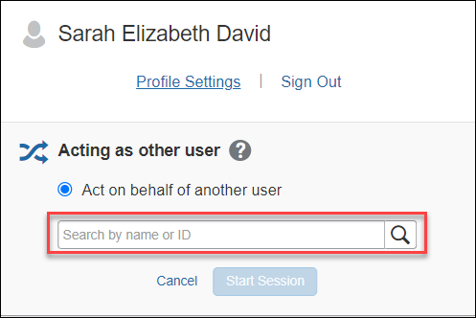
To return to your own tasks, click Acting as and then Done acting for others button.

Send Receipt Images to Travelers Available Receipts Library
The Delegate cannot set up an email account when they are delegating, nor can they use the verified email account they have set up for their own profile to populate another user's Available Receipts Gallery. However, the delegate can upload receipt images to Concur for attachment to the line item of the Traveler/Cardholder’s report they are acting on. The following steps should be completed during profile setup:
- The Traveler/Cardholder must verify his/her own email address in his/her profile.
- The Delegate must verify his/her own email address is in his/her profile.
- The delegate must have the correct delegation permission (can view receipts, can attach receipt, etc.). To update delegate permissions, go to Profile > Profile Settings > Expense Delegates > Add a Delegate > select Can Prepare and Can View Receipts.
- Then, the Delegate can email receipts to receipts@concur.com with the correct image extensions and size (must be a .png, .jpg, .jpeg, .pdf, .html, .tif or .tiff file; 5 MB limit per file).

The Delegate must put the Traveler/Cardholder’s email address in the subject line.
- The receipt will show in the Traveler/Cardholder’s Available Receipts gallery within three minutes.

Printing an Expense Report
To Preview and Print the Expense Report
- On the Expense Report page, click Print/Share, and then select *CSU-Detailed Report with Summary Data.
- Click Print or Save as PDF or Email to get the complete packet for expense report (includes copies of receipts attached). Please note, copies are retained in Concur according to our CSU retention guidelines and maintaining duplicative copies elsewhere is not required of departments.

Support Documents for Chancellor’s Office/CPO Submission

CPOs are inter-CSU transactions between a campus and the CO or another campus. The CO facilitates moving funds between campuses by way of a CPO (journal entry). The CO generally requires copies of the expense report and related receipts, depending on the allocation involved. The awarding department at the CO/campus will generally give recipients/participants instruction on what will be reimbursed, and the department will have to decide if they will cover any variance that may occur between reimbursement allowed by CSU procedures and allocation received by the CO/campus.
Sometimes the CO asks for receipts that are not required by the policy – it will be important for travelers/departments to retain those additional copies ifa CPO is in play or until these additional requirements are no longer exercised.
- In Concur, go to the expense menu and, to the right of the Report Library view, click the drop down to select the Date Range to pull up submitted expense reports.
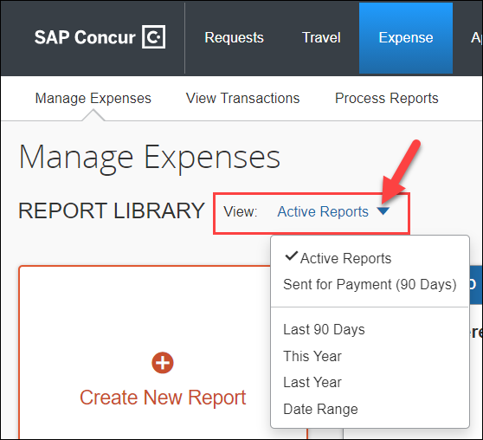
- Select the correct expense report and then click “Print/Share” link and select “CSU-Detailed Report with Summary Data.” Print this report to PDF. The PDF version will also contain the related receipts that were attached. This file can then be sent to the appropriate CO contact or campus accounting team for CPO support.

Correcting and Resubmitting an Expense Report

If an error is found within your expense report, it may be returned by the expense report Approver or Processor. The Approver or Processor will include a comment explaining why the report was returned to you.
To identify and correct expense reports requiring resubmission:
- On the home page, in the Quick Task Bar, click the Open Reports tile. In the Manage Expenses section of the page, the report appears with Returned header on the report tile. The approver's comment appears below the amount.
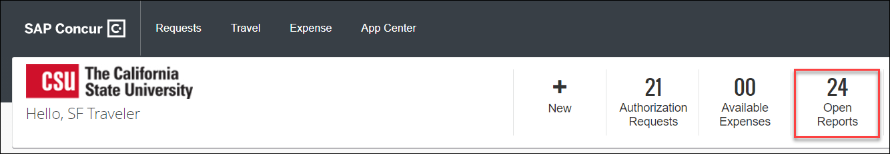
- Click the report tile to open the report.
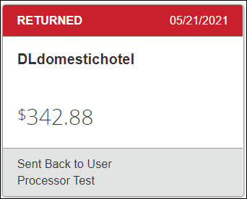
- Make the requested changes.
- Click Submit Report.

